
School of Computing and Engineering Sciences

BBT 2202: Advanced Object-Oriented Programming

Lab Practical Assessment: Classes & Objects

000000 – Surname, First-name Second-name.

Instructions
- This is an individual assignment; you can work in pairs but submit different work.
- Answer every question on this document.
- Maintain the document format when answering EXCEPT when writing code.
- Provide additional information where you feel diagrams may not be enough (using comments).
- Once you are done answering, convert the document to .pdf format for submission.
Objective:
To practice object-oriented programming in Java by:
- Reading a UML Class Diagram and creating a class with attributes and methods.
- Understanding encapsulation, object creation and instantiation.
Prerequisites:
- NetBeans 22 (or later) installed on your computer.
- Basic understanding of programming concepts.
Part A : Tutorial
Step 1: Open NetBeans 22 and Create a New Project
- Launch NetBeans IDE.
- Click File → New Project.
- Select Java with Ant → Java Application and click Next.
- Name the project ’OOPBasics2’.
- Uncheck “create main class”, then click Finish.".
Step 2: Create the Student class
- Right-click on the Source Packages folder in the Projects window.
- Select New → Java Package.
- Name the package ‘strathmore’ and click finish.
- Right-click on the ‘strathmore’ package.
- Select New → Java Class.
- Name the class ’Student’ and click Finish.
Step 3: Write code for the Student Class
Challenge yourself to implement the UML Class diagram based on what we learnt in class.
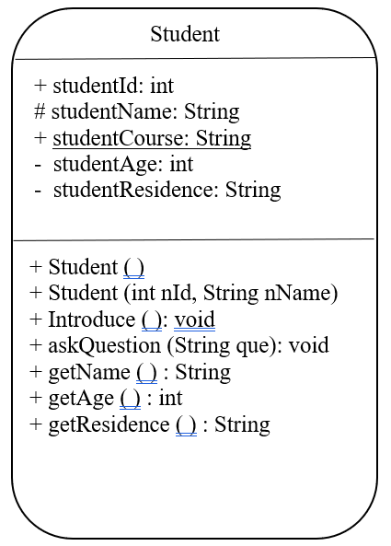
The following steps provide a guide on how implement the class diagram show above
- After creating the Student.java file in Step 2, navigate to the same file within the two curly-brackets in the file, start writing your code.
- Declare the five attributes, while paying attention to the access and operational modifiers as indicated. (Hint: + is for public, - is for private, * or # is for protected). Notice studentCourse has been underlined, what does that indicate?
- Declare and implement the Seven (7) methods as shown in the diagram
  - The first two are constructors, notice how they share they share the same name as he class (Student with a capital S) and have no return data. What is the difference between the two?
  - For the next five methods, you are free to give the implementations as you see fit. At the very least, the introduce method should output the student’s name, id and course in any order.
- The code for all the steps above (final class implementation can be found at the end of this document).
Step 4: Create the ‘main’ or ‘test’ or ‘Driver’ class
- Right-click on the ‘strathmore’ package.
- Select New → Java Class.
- Name the class ‘StudentDriver’ and click Finish.
- Inside the two curly brackets implement the main method in java and :
  - Create an Object, s1. Instantiate object s1, using the default constructor. Assign values to the id, name and course attributes.
  - Create an Object, s2. Instantiate an object s2, using a parameterised constructor. Assign values to the id and name attributes. (Which one is first between the two? Notice how we do not assign a value to the course attribute, how will this affect s2?)
  - Invoke the introduce method for both objects.
  - Invoke the get Residence method and output the results. (Hint: Append the output to a String message like “I live in/at/ “).
  - Invoke any other method and have fun with the assignment
- The sample code for this can be found at the end of the document.
Step 5: Run the code
- Right-click on the Test.java or StudentDriver.java file.
- Click Run File.
- Observe the output in the Output Window for the following (sample).
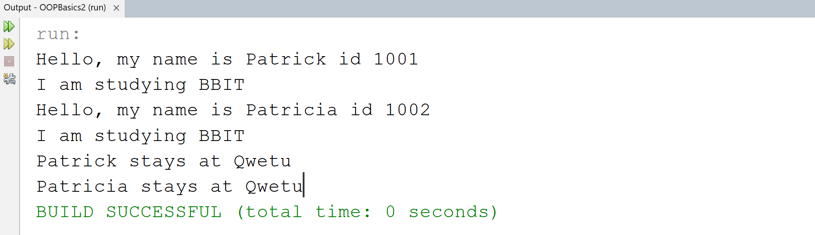

Part B – Questions
- What is the difference between a parameterized constructor and a no-argument constructor (default constructor).
A static variable is shared across all instances of a class but a non-static variable is unique to each object.
- What is the difference between a static and non-static (instance) variable according to your own understanding
A parameterized constructor takes arguments to initialize values while a no-argument constructor does not.

- Paste the code for the complete student class
public class Student {
private String studentId;
private String studentName;
protected String studentCourse;
private int age;
private String residence;

public Student() {
this.studentId = "192044";
this.studentName = "Beryl Orutwa";
this.studentCourse = "BBIT";
this.age = 20;
this.residence = "Hostel A";
}

public Student(String id, String name) {
this.studentId = id;
this.studentName = name;
this.studentCourse = "BBIT";
this.age = 18;
this.residence = "Hostel A";
}

public void introduce() {
System.out.println("Hi, I am " + studentName + " (ID: " + studentId + "), studying " + studentCourse + ".");
}

public String getResidence() {
return residence;
}

public void setCourse(String course) {
this.studentCourse = course;
}

public void setAge(int age) {
this.age = age;
}

public void setResidence(String residence) {
this.residence = residence;
}

}
- Paste the code for the complete Test or StudentDriver class
public class StudentDriver {
public static void main(String[] args) {
Student s1 = new Student();
s1.setCourse("BBIT");
s1.setAge(20);
s1.setResidence("Hostel B");

Student s2 = new Student("192570", "Derrick Barasa");

s1.introduce();
System.out.println( "I live in " + s1.getResidence());

s2.introduce();

System.out.println("And I live in " + s2.getResidence());

s2.setCourse("BBIT");

}

}
- Bonus: Design a UML diagram for a different object, such as Lecturer or Car. Upload the new code on eLearning, on a separate pdf document.

Code for the Student class
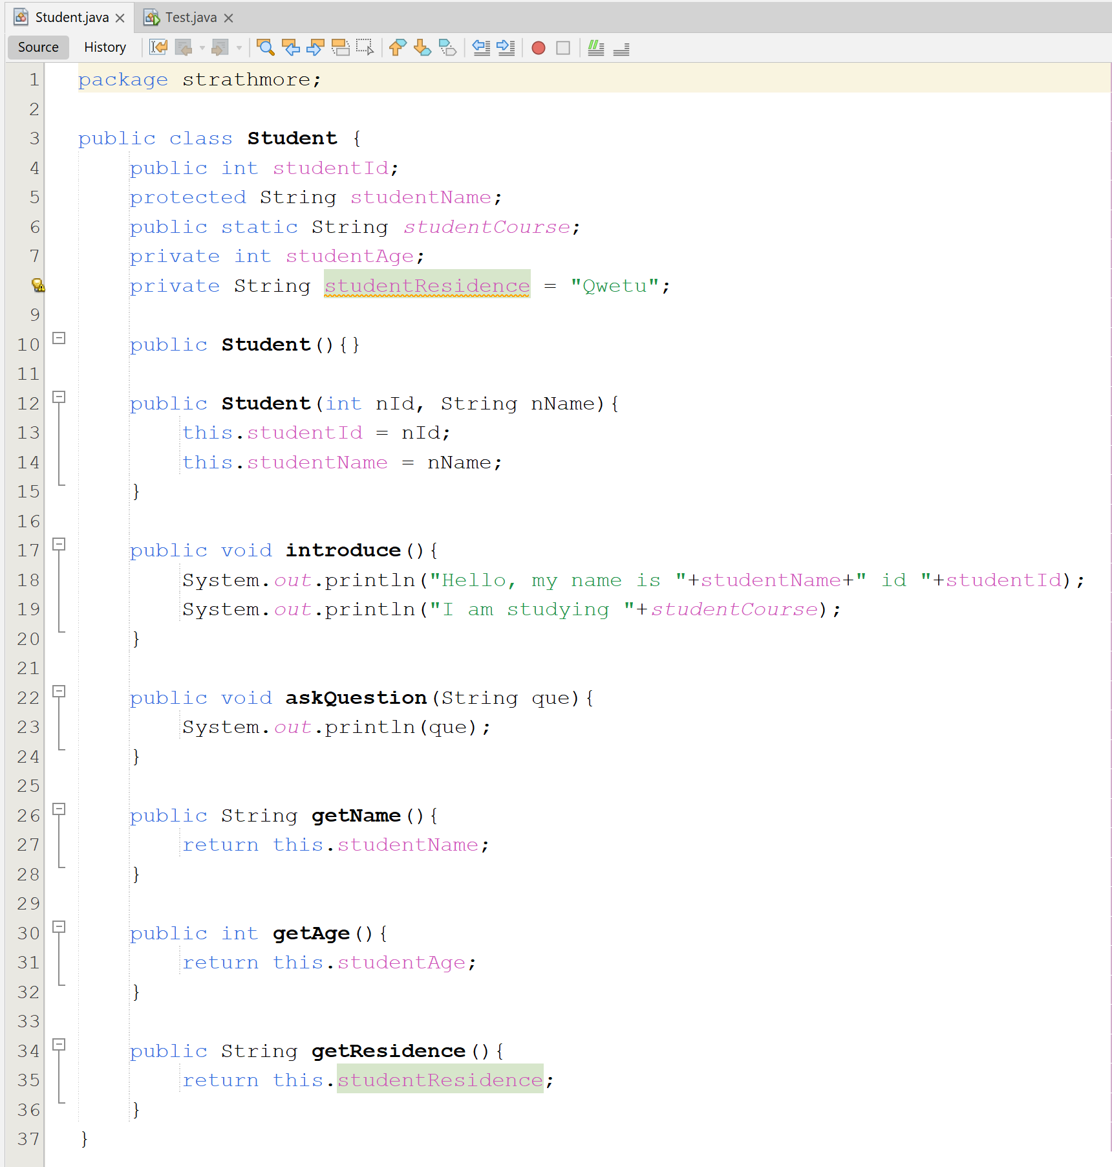

Code for the StudentDriver or Test class
